**Introduction**

In this hands-on lab, we will use Kinetis Design Studio to create 4 tasks named Task_A, Task_B, Task_C and Task_D which enter in an endless loop printing a message in a terminal.

**Resources**

PC running Windows 7 with the following software:

• Kinetis Design Studio (KDS) v2.0.0

• MQX for KSDK v1.1.0

Hardware:

• FRDM-K64F

1. **Implementation**
   1. By now a ‘*New MQX RTOS for KSDK Project Wizard’* does not exists. For this Lab use **‘MQX for KSDK Lab 2 - Base Project’**.

**Note:** If you want to know how to create a base project see the **‘Appendix’** in this document.

* 1. Define Task_A in the Task_Template_Struct. Use the parameters below for this task.
  2. Task Number 2
  3. Task name Task_A
  4. Stack size 1500
  5. Priority 10
  6. NOT Auto Start.
  7. Task_Template_Struct should look like this.

TASK_TEMPLATE_STRUCT MQX_template_list[] =

{

/* Task number, Entry point, Stack, Pri, String, Auto? */

{MAIN_TASK, Main_task, 1500, 9, "main", MQX_AUTO_START_TASK},

{2, Task_A, 1500, 10, "Task A", 0 },

{0, 0, 0, 0, 0, 0, }

};

* 1. Add a macro in main.c to replace the task number in the Task_Template_Struct. For example.

**#define** TASK_A 2

TASK_TEMPLATE_STRUCT MQX_template_list[] =

{

/* Task number, Entry point, Stack, Pri, String, Auto? */

{MAIN_TASK, Main_task, 1500, 9, "main",MQX_AUTO_START_TASK},

{TASK_A, Task_A, 1500, 10, "Task A", 0 },

{0, 0, 0, 0, 0, 0, }

};

* 1. According to the instructions the task’s body should look as shown below. Use function _**time_delay()** to make a 500mS delay to be able to see output in the UART and let other tasks run. See **Freescale MQX™ RTOS Reference Manual.pdf** for details about time delay function and its parameters. You can find it in ***<KSDK_install_dir>/rtos/mqx/doc****.*

**void** **Task_A**(uint32_t initial_data)

{

**while**(1){

printf("\n This is Task A \n");

**_time_delay**(500);

}

}

* 1. Add the function prototype in main.c.

**void** **Task_A** (uint32_t);

* 1. Repeat steps 1 to 5 for Task_B, Task_C and Task_D.
  2. In Main_Task create one instance of Task_A, Task_B, Task_C and Task_D using **_task_create**().You can see **Freescale MQX™ RTOS Reference Manual.pdf** for details about tasks functions and their parameters. You can find it in ***<KSDK_install_dir>/rtos/mqx/doc****.*
  3. The task id number must be saved in a variable of type _task_id.
  4. A message to a terminal must be sent whether the task was created successfully or not and show the error number in case it fails.
  5. After creating all tasks, Main_Task must remain blocked using **_task_block**() function.

_task_id ta, tb, tc, td;

**void** **Main_task**(uint_32 initial_data)

{

printf("\n Using Tasks \n");

ta = **_task_create**(0,TASK_A,0);

**if** (ta == MQX_NULL_TASK_ID)

{

printf("Task_A could not be created. Error: 0x%X \n", ta);

}

**else**

{

printf("Task_A was created\n");

}

tb = **_task_create**(0,TASK_B,0);

**if** (tb == MQX_NULL_TASK_ID)

{

printf("Task_B could not be created. Error: 0x%X \n", tb);

}

**else**

{

printf("Task_C was created\n");

}

tc = **_task_create**(0,TASK_C,0);

**if** (tc == MQX_NULL_TASK_ID)

{

printf("Task_C could not be created. Error: 0x%X \n", tc);

}

**else**

{

printf("Task_C was created\n");

}

td = **_task_create**(0,TASK_D,0);

**if** (td == MQX_NULL_TASK_ID)

{

printf("Task_D could not be created. Error: 0x%X \n", td);

}

**else**

{

printf("Task_D was created\n");

}

**_task_block**();

}

* 1. Debug the application. What output do you get in the terminal?
  2. Edit the application.
     1. Main_Task must create Task_A and remain blocked using **_task_block**() function.
     2. Task_A must create Task_B and remain blocked using **_task_block**().
     3. Task_B must create Task_C and destroy itself using **_task_destroy**(MQX_NULL_TASK_ID).
     4. Task_C must create Task_D and destroy itself using **_task_destroy**(MQX_NULL_TASK_ID).
     5. Task_D must put Task_A in ready state using **_task_ready**(). You will need to use **_task_get_td**() to get a pointer to the task descriptor which is the parameter that **_task_ready**() needs.
     6. Finally Task_D must destroy itself using **_task_destroy**(MQX_NULL_TASK_ID).

See **Freescale MQX™ RTOS Reference Manual.pdf** for details about tasks functions and their parameters. You can find it in ***<KSDK_install_dir>/rtos/mqx/doc***.

* 1. Debug the application. What output do you get?

**That now completes Lab 3.**

1. **Code**

**#include** <mqx.h>

**#include** <bsp.h>

**#define** MAIN_TASK 1

**#define** TASK_A 2

**#define** TASK_B 3

**#define** TASK_C 4

**#define** TASK_D 5

**void** **Main_task**(uint_32);

**void** **Task_A** (uint_32);

**void** **Task_B** (uint_32);

**void** **Task_C** (uint_32);

**void** **Task_D** (uint_32);

TASK_TEMPLATE_STRUCT MQX_template_list[] =

{

/* Task number, Entry point, Stack, Pri, String, Auto? */

{MAIN_TASK, Main_task, 1500, 9, "main", MQX_AUTO_START_TASK},

{TASK_A, Task_A, 1500, 10, "Task A", 0},

{TASK_B, Task_B, 1500, 10, "Task B", 0},

{TASK_C, Task_C, 1500, 10, "Task C", 0},

{TASK_D, Task_D, 1500, 10, "Task D", 0},

{0, 0, 0, 0, 0, 0, }

};

_task_id ta, tb, tc, td;

**void** **Main_task**(uint_32 initial_data)

{

printf("\n Using Tasks \n");

ta = **_task_create**(0,TASK_A,0);

**if** (ta == MQX_NULL_TASK_ID)

{

printf("Task_A could not be created. Error: 0x%X \n", ta);

}

**else**

{

printf("Task_A was created\n");

}

**_task_block**();

}

**void** **Task_A**(uint_32 initial_data)

{

_task_id tb;

**while**(1){

printf("\nThis is Task A \n");

**_time_delay**(500);

tb = **_task_create**(0,TASK_B,0);

**if** (tb == MQX_NULL_TASK_ID)

{

printf("Task_B could not be created. Error: 0x%X \n", tb);

}

**else**

{

printf("Task_B was created\n");

}

**_task_block**();

}

}

**void** **Task_B**(uint_32 initial_data)

{

_task_id tc;

**while**(1){

printf("\nThis is Task B \n");

**_time_delay**(500);

tc = **_task_create**(0,TASK_C,0);

**if** (tc == MQX_NULL_TASK_ID)

{

printf("Task_C could not be created. Error: 0x%X \n", tc);

}

**else**

{

printf("Task_C was created\n");

}

**_task_destroy**(MQX_NULL_TASK_ID);

}

}

**void** **Task_C**(uint_32 initial_data)

{

_task_id td;

**while**(1){

printf("\nThis is Task C \n");

**_time_delay**(500);

td = **_task_create**(0,TASK_D,0);

**if** (td == MQX_NULL_TASK_ID)

{

printf("Task_D could not be created. Error: 0x%X \n", td);

}

**else**

{

printf("Task_D was created\n");

}

**_task_destroy**(MQX_NULL_TASK_ID);

}

}

**void** **Task_D**(uint_32 initial_data)

{

**while**(1){

printf("\nThis is Task D \n");

**_time_delay**(500);

**_task_ready**(**_task_get_td**(ta));

**_task_destroy**(MQX_NULL_TASK_ID);

}

}

/* EOF */

1. **Appendix**

To create a new project you will have to copy/paste the hello_frdmk64f (project imported in lab 1) into your workspace and rename it. When you copy/paste a project into your workspace, your sources folder is linked to the original one, so if you change anything on your new project it will be changed in the original one too. To avoid this problem you will have to erase the sources folder of your new project and create a new one with the same name (this one will not be linked to the previous project).

* 1. If your workspace is not the same that the hello_frdmk64f project you will have to modify the paths of the project. To do this you will have to go to **Project->Properties->C/C++ Build ->Settings**
  2. You will have to change the every single path of the program, to do this you will have to look for the right path the program is referring. For example, in the

**Cross ARM GNU Assembler -> Includes** the first path will be **${ProjDirPath}/../../../../../../config/mcu/mk64f120m**

You will have to look into the installation folder **(C:\Freescale\KSDK_1.1.0)** the last directories of this path. In this case you will find it at

**C:\Freescale\KSDK_1.1.0\rtos\mqx\config\mcu\mk64f120m**.

* 1. Once you get the correct path you will have to click the add option.

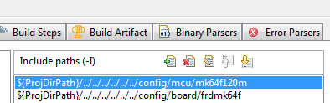

* 1. This window will appear, here you will have to add the correct path and substitute the **C:\Freescale\KSDK_1.1.0** with **${KSDK_PATH}** and then click ok.(Note: is important to have defined KSDK_PATH as an environment variable)

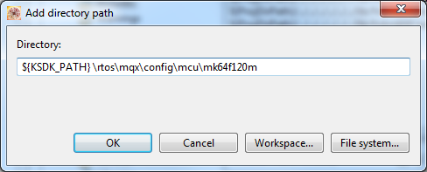

* 1. Once you have added this new path you can erase the other one. You will have to repeat this steps in the next folders.

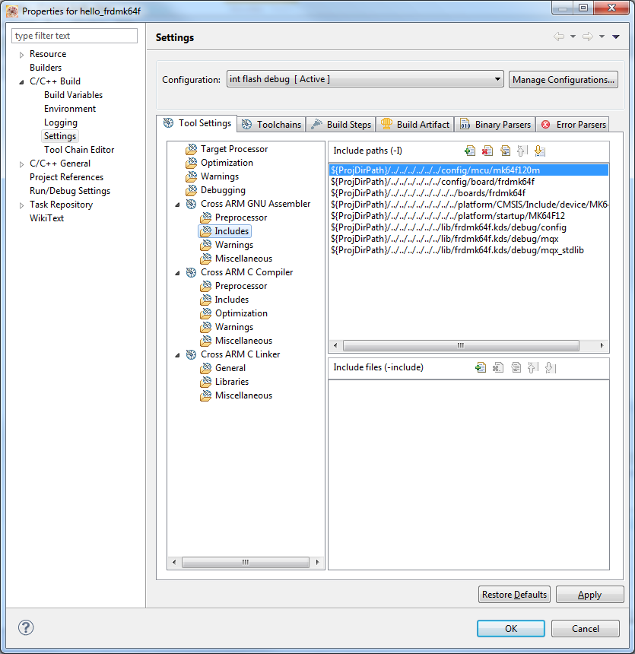

* 1. Your new paths will have to see as follows.

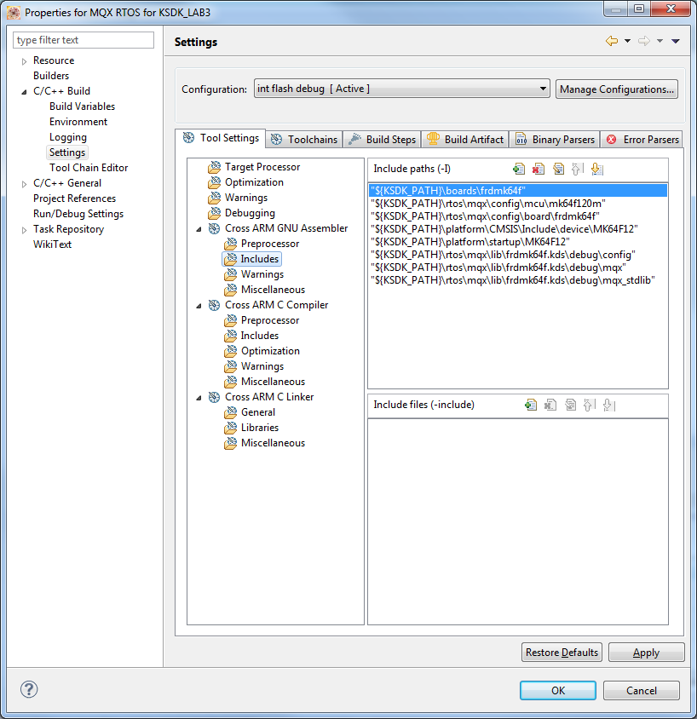

* 1. Once you change every single path you will be able to compile and debug your new project. All this process is necessary because the MQX RTOS for KDS wizard is still in development.